|  |  |
| --- | --- |
| Name: Sayyed Sohail Rashid | Course Name: DC-LAB |
| Class: BE-CO | Batch: 01 |
| Roll no: 18CO48 | Experiment No: 07 |

Aim : To Implement the Load Balancing.

Code:

LoadBalancing.java

import java.util.*;

public class LoadBalancing{

static void printLoad(int servers, int processes) {

int each=processes/servers;

int extra=processes%servers;

int total=0;

int i=0;

for(i=0; i<extra; i++) {

System.out.println("Server "+(i+1)+" has "+(each+1)+" Processes");

}

}

while(true) {

printLoad(servers, processes);

System.out.println("1.Add Servers 2.Remove Servers 3.Add Processes 4.Remove Processes 5.Exit ");

switch(sc.nextInt()) {

case 1:

System.out.println("How many more servers to add ? ");

servers+=sc.nextInt();

break;

case 2:

System.out.println("How many more servers to remove ? ");

servers-=sc.nextInt();

break;

case 3:

System.out.println("How many more Processes to add ? ");

processes+=sc.nextInt();

break;

case 4:

System.out.println("How many more Processes to remove ? ");

processes-=sc.nextInt();

break;

case 5:

return;

}

}

}

}

Output:

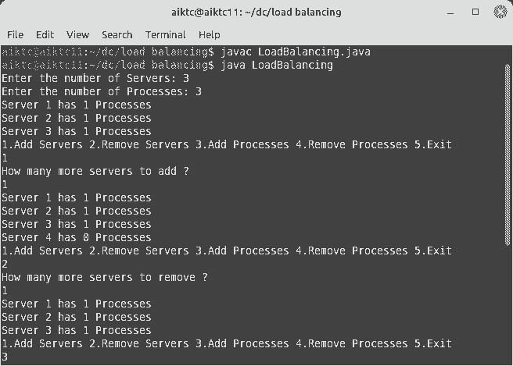

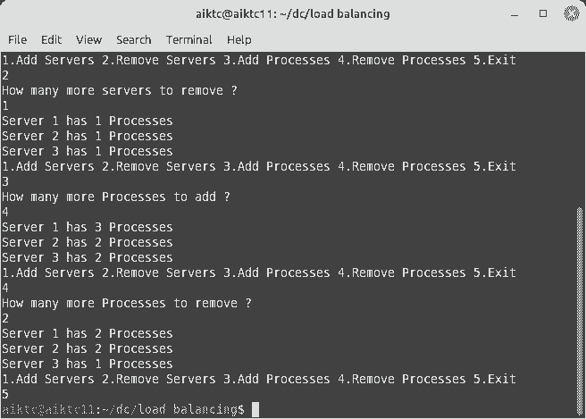

Conclusion:

Load Balancing has been implemented with adding and removing the process and servers.